Taller de Inglés 3° Medio
UNIDAD: NIVELACIÓN

PUNTAJE  IDEAL | 32  PUNTOS | PUNTAJE  OBTENIDO | PUNTOS | CALIFICACION

OBJETIVOS |  |  | CONTENIDO
- Identificar información de un texto discriminando información relevante de detalles sin trascendencia.  - Reconocer estructura de pasado perfecto para indicar situaciones que ocurrieron antes del pasado completando oraciones.  - Reconocer vocabulario temático completando tabla. |  |  | - Comprensión Lectora.  - Verbos.  - Pasado Perfecto
HABILIDADES |  |  | INSTRUCCIONES
- Identificar información general y especifica  - Reconocer vocabulario  - Aplicar vocabulario |  |  | - Lee atentamente cada ítem, instrucción o actividad.  - Escriba sus respuestas en la hoja de respuestas.  - Maestra: Ana María Alvear Farías.  Consultas: aalvear@donboscoantofagasta.cl
IDENTIFICATION
NAME
GRADE |  | Nº LIST: |  | DATE:

PAST PERFECT
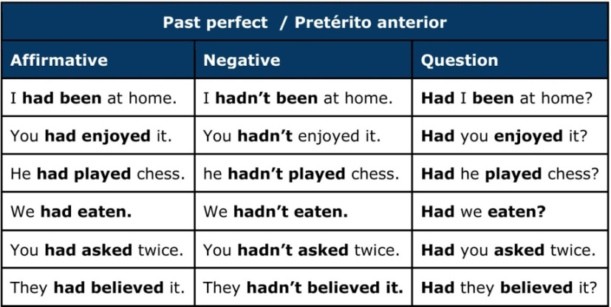
El Pasado Perfecto se forma con “had” + pasado participio del verbo principal.

Choose the right answer... (1 point each)
Elija la opción correcta.

1. ______they _____ to her before?

A) had / spoken B) did / spoke C) had spoke

2. I ______ never _____ her before.

A) had / seen B) has / seen C) did / seen

3. We arrived at 8:05, but the train _____ already ________
A) had leaved B) has left C) had left

4. Sarah thought she ________ to that zoo before.

A) were B) been C) had been

5. Where _____ the security guard ________?

A) had went B) had gone C) had go

6. Look! Somebody ___________ the windows open.

- Had left B) Had leave C) Had lived

7. Her bicycle wasn’t there because a friend ___________ it without asking her.

- Had left B) Had taken C) Had enjoyed

READING COMPREHENSION.

GETTING AWAY FROM IT ALL.

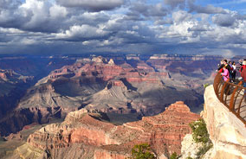
Last year, my family decided to do something different for our vacation. We had always gone to the beach, and spent our time sunbathing and relaxing. But we wanted a more active vacation. So we chose a walking trip around the Grand Canyon. I’d never done anything like it before so I felt nervous before we left.
We started in Las Vegas, and a small truck left us at the starting point for our first day of hiking. The first day was terrible! My shoes were too small and by lunchtime I was beginning to think that I never wanted to see my bag again I was so hungry because there wasn’t enough food!
The first night was awful, too. I didn’t sleep and I was so cold. And in the morning we had to wash in cold water!
But I started to enjoy it more and more. We walked about 15 km a day. That seemed a lot at the beginning of the trip, because I’d never done any walking before, but by the end of the vacation I was a lot healthier and wasn’t so tired. The things we saw were amazing. I took lots of photos, and the best day of all was when we took a helicopter flight over the Grand Canyon! Wow!
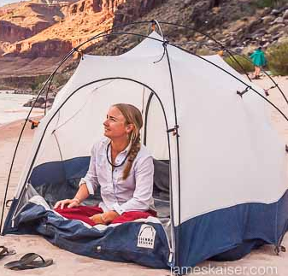
Did I enjoy it? Yes. It’s a great way to see nature and get healthy.
You can also hire bikes and see the Grand Canyon that way. But still felt great to get back to Las Vegas to spend a night in a hotel, have a chance to go sightseeing, and eat out in the city!

Read the article about Rachel’s vacation.
Are the sentences 8-14 Right (A) or Wrong (B)?
If there is not enough information in the article choose “Doesn’t say” (C) (1 point each)
Lea el artículo acerca de las vacaciones de Rachel. ¿Las oraciones 8-14, son correctas (A) o Incorrectas (B)? Si no hay suficiente información en la lectura elija ”El texto no lo menciona” (C)

- Rachel had been on active vacations before.

- Right B) Wrong C) Doesn’t say

- She felt excited before the trip.

A) Right B) Wrong C) Doesn’t say

- Rachel has a very big family.

A) Right B) Wrong C) Doesn’t say

- Rachel didn’t enjoy the first day.

A) Right B) Wrong C) Doesn’t say

- For Rachel, the walking got easier during the vacation.

A) Right B) Wrong C) Doesn’t say

- Rachel and her family hired bikes to see the Grand Canyon.

A) Right B) Wrong C) Doesn’t say

- Rachel was disappointed to return to city life.

A) Right B) Wrong C) Doesn’t say

For questions 15-18:
Choose the correct option to answer the questions. (1 point each)
Elija la opción correcta para contestar preguntas.

- Why did Rachel and her family decide to take a walking vacation?

- They felt nervous before they left.
- They had always gone for a walking.
- They wanted a more active vacation.

- What problem did Rachel have on the first night?

- She was so cold. She couldn’t sleep.
- Her shoes were too small.
- She had to wash with cold water.

- How did Rachel feel about walking at the end of the vacation?

- It seemed a lot.
- It was amazing.
- She wasn’t so tired.

- What part of the vacation did she enjoy the most?

- When they took a helicopter flight over the Grand Canyon.
- When they walked about 15 km a day.
- When they hired bikes and see the nature.

For questions 19-23. Read the information about language courses and the e-mail messages.
Fill in the information on the Course Booking form. (1 point each)

Para las preguntas 19-23. Lee la información acerca de cursos de idiomas y el mensaje.
Completa la información en la tabla.

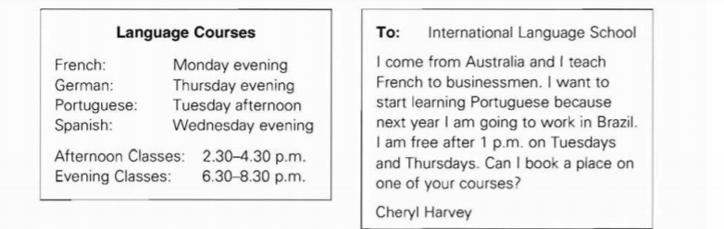

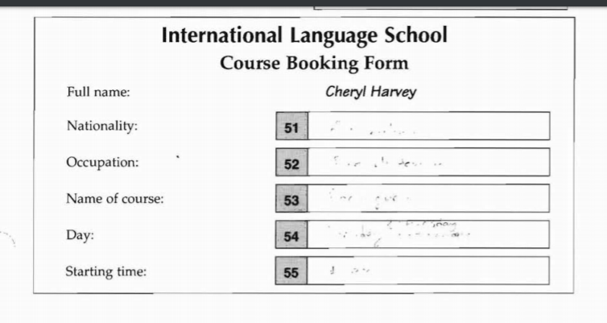
23
22
21
20
1999
Complete the table: (1 point each)
Complete la tabla.

INFINITIVE | SIMPLE PAST | PAST PARTICIPLE | SPANISH
Spend | 24) | 25) | 26)
Do | 27) | 28) | 29)
See | 30) | 31) | 32)

HOJA DE RESPUESTA

ALUMNO: ____________________________________ N° LISTA: __________ CURSO: __________

1 | 2 | 3 | 4 | 5 | 6 | 7 | 8 | 9

10 | 11 | 12 | 13 | 14 | 15 | 16 | 17 | 18

19
23
22
21
20

INFINITIVE | SIMPLE PAST | PAST PARTICIPLE | SPANISH
Spend | 24) | 25) | 26)
Do | 27) | 28) | 29)
See | 30) | 31) | 32)

