Taller Inglés 4°Medio
UNIDAD: NIVELACIÓN

PUNTAJE  IDEAL | 38  PUNTOS | PUNTAJE  OBTENIDO | PUNTOS | CALIFICACION

OBJETIVOS |  |  | CONTENIDO
- Analizar textos escritos identificando las ideas principales y reconociendo detalles.  - Reconocer y aplicar reglas gramaticales del condicional 2. |  |  | - Comprensión Lectora.  - Condicional 2.
HABILIDADES |  |  | INSTRUCCIONES
- Identificar información general y especifica  - Reconocer vocabulario  - Aplicar vocabulario |  |  | - Lee atentamente cada ítem, instrucción o actividad.  - Escriba sus respuestas en la hoja de respuestas.  - Maestra: Ana María Alvear Farías.  - Consultas: aalvear@donboscoantofagasta.cl
IDENTIFICATION
NAME
GRADE |  | Nº LIST: |  | DATE:

CONDITIONAL TYPE 2

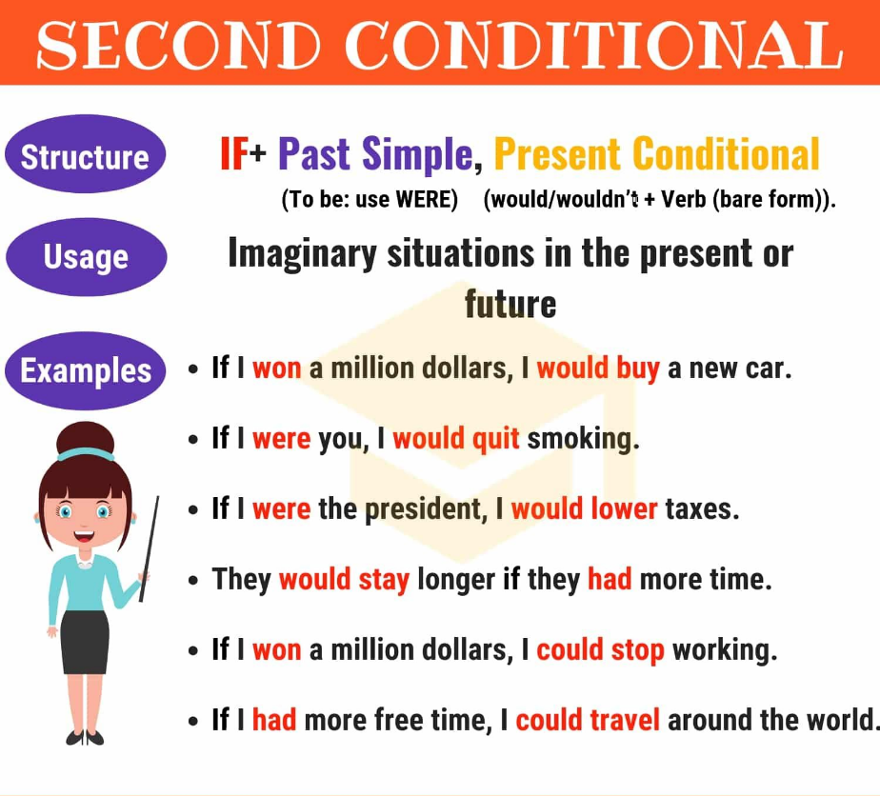 | Condicional 2:  Consta de dos cláusulas:  If Clause and the result  - IF Clause: Usa pasado simple.  Aff: Verb Simple past  Neg: Didn’t + Verb Infinitive  Verb to be: WERE (all persons)  - Resultado: Usa Presente condicional  Aff: Would (‘d) + Verb infinitive  Neg: wouldn’t + Verb Infinitive  También podemos usar:  Could + Infinitive  Couldn’t + infinitive

CHOOSE THE CORRECT OPTION TO COMPLETE THE SENTENCE ( 1 POINT EACH)
Elija la opción correcta para completar la oración.

- If I _________ the answer, I’d tell you.

- Know B) knew C) would know

- I wouldn’t be so worried if I ________________ so many exams.

- Hadn’t B) couldn’t have C) didn’t have

- __________ you ______ with your friends if you were allowed?

- Would / go B) Did / go C) will/ go

- I’d travel around the world if I _______________ a millionaire.

- Was B) were C) would be

- He wouldn’t be able to write an e-mail if he ____________ a computer.

- Didn’t have B) wouldn’t have C) did had

- Tom _____________ his exams if he ______________ hard, but he’s really lazy.

- Would have / ate B) would pass / studied C) would take / felt

- Ellen’s never eaten Chinese food, but I’m sure he ________________ if she ______________ it.

- Would lose / cleaned B) would take / felt C) would enjoy / tried

MATCH THE SENTENCES HALVES: (1 point each)
Una las dos clausulas para formar una oración.

- If I knew her number,  - She’d get better grades at school  - If you played more sports  - I’d be really happy  - If I had lots of money,  - If I found my best friend’s journal, | - I’d buy a guitar.  - I wouldn’t read it.  - if she studied harder.  - if Jim invited me to his party.  - I’d call her.  - you’d feel better.

READING COMPREHENSION

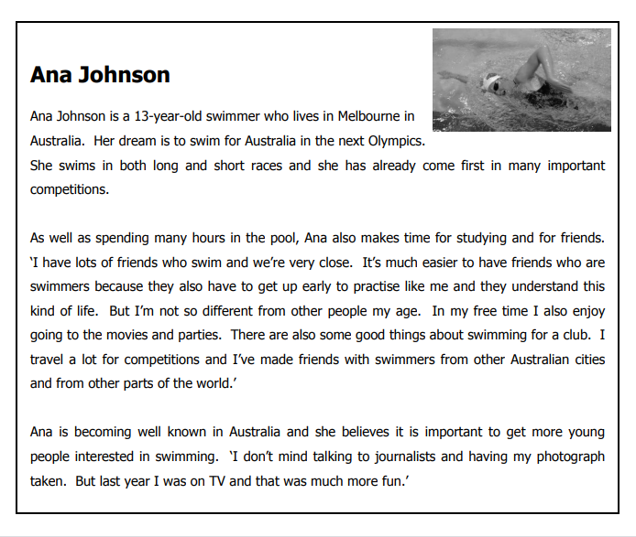
Read the article about a young swimmer.
Are the sentences 14-21 Right (A) or Wrong (B)?
If there is not enough information in the article choose “Doesn’t say” (C) (1 point each)
Lea el artículo acerca de una joven nadadora. ¿Las oraciones 14-21, son correctas (A) o Incorrectas (B)? Si no hay suficiente información en la lectura elija ”El texto no lo menciona” (C)

- Ana’s home is in Melbourne.
A Right B Wrong C Doesn’t say

- Ana hopes she will become an Olympic swimmer.

A Right B Wrong C Doesn’t say

- Ana knows that she is better at short races than long ones.

A Right B Wrong C Doesn’t say

- Ana has won a lot of swimming competitions.

A Right B Wrong C Doesn’t say

- It is difficult for Ana to make friends with other people who swim.

A Right B Wrong C Doesn’t say

- Ana likes doing the same things as other teenagers.

A Right B Wrong C Doesn’t say

- Ana has met people from different countries at swimming competitions.

A Right B Wrong C Doesn’t say

- Ana prefers speaking to journalists to being on television.

A Right B Wrong C Doesn’t say

Read the article about two Canadian boys.
Are sentences 22–29 ‘Right’ (A) or ‘Wrong’ (B)?
If there is not enough information to answer ‘Right’ (A) or ‘Wrong’ (B), choose
‘Doesn’t say’ (C).
Lea el artículo acerca de dos jóvenes Canadienses. ¿Las oraciones 22-29, son correctas (A) o Incorrectas (B)? Si no hay suficiente información en la lectura elija ”El texto no lo menciona” (C)

- Peter and Frazer are both teenagers.
A Right B Wrong C Doesn’t say

- Peter and Frazer go to the same school in Canada.
A Right B Wrong C Doesn’t say

- Peter and Frazer like doing different sports to their friends.
A Right B Wrong C Doesn’t say

- For the past few months, the boys have spent most of their time outside.
A Right B Wrong C Doesn’t say

- Peter and Frazer prefer playing computer games to doing their homework.
A Right B Wrong C Doesn’t say

- It took less than 200 hours to finish the new computer game.
A Right B Wrong C Doesn’t say

- In the computer game, you see a picture of a word and hear it spoken.
A Right B Wrong C Doesn’t say

- Students in other countries have said they would like to use the computer game.
A Right B Wrong C Doesn’t say

COMPLETE THE TABLE: (1 point each)

Completa la table.

INFINITIVE | SIMPLE PAST | PAST PARTICIPLE | SPANISH
Understand | 30) | 31) | 32)
Keep | 33) | 34) | 35)
Get | 36) | 37) | 38)

HOJA DE RESPUESTA

NOMBRE DEL ALUMNO: __________________________________________

CURSO: ________________________________________________________

1 | 2 | 3 | 4 | 5 | 6 | 7 | 8 | 9 | 10

11 | 12 | 13 | 14 | 15 | 16 | 17 | 18 | 19 | 20

21 | 22 | 23 | 24 | 25 | 26 | 27 | 28 | 29

INFINITIVE | SIMPLE PAST | PAST PARTICIPLE | SPANISH
Understand | 30) | 31) | 32)
Keep | 33) | 34) | 35)
Get | 36) | 37) | 38)

